**AMERICAN INTERNATIONAL UNIVERSITY–BANGLADESH (AIUB)**

**Dept. of Computer Science**

**Faculty of Science and Technology**

**CSC2210: OBJECT ORIENTED PROGRAMMING 2**

**Spring 2024-2025**

**Section: [*K*]**

**Group Name: C# Crew**

**Project Report On**

*Travel Management System*

**Supervised By**

**Abrar Fahad**

**Submitted By:**

|  |  |
| --- | --- |
| **Name** | **ID** |
| **1. MD RAMIM ISLAM** | **23-54272-3** |
| **2. MITU RANI ROY** | **23-54949-3** |
| **3. TOUSIF AHMMED** | **23-53717-3** |

|  |  |  |  |  |  |
| --- | --- | --- | --- | --- | --- |
| **CO2:** Display and verify the mean of a real-life Project using the concepts of C# Graphical User Interface based environment with database integration to depict a desktop-based application. | | | | | |
| **Assessment Criteria** | **Not Attended/ Incorrect (0)** | **Inadequate  (1-2)** | **Average (3)** | **Good  (4)** | **Excellent (5)** |
| **Evaluation Criteria** | **Evaluation Definition** | | | | **Total =** |
| Requirement fulfillment | Properly demonstrate a real-life scenario-based project with proper functional requirement identification for the Object-Oriented Programming project development activities. | | | |  |
| Validation | Ensuring the ability of students’ proper demonstration on validation forms in their system in terms of dealing with the data. | | | |  |
| Verification | Identifying if the students can verify the system data along with proper functional requirements in terms of data flow. | | | |  |

Table of Contents: Page no.

1. Chapter :01 (Introduction)---------------------------------------------------------------------- 03

2. Chapter :02(User Story)------------------------------------------------------------------------- 03

3. Chapter :03 (ER Diagram)---------------------------------------------------------------------- 05

4. Chapter :03 (SQL Queries)--------------------------------------------------------------------- 06

5. Chapter:04 (Screenshots) ---------------------------------------------------------------------- 09

**Chapter :01 (Introduction)**

The Travel Management System is a database-driven application developed to simplify and automate the process of planning, booking, and managing travel trips. This system provides a complete solution for managing trips, customers, and payments in an organized and efficient way. It is designed to meet the needs of travel agencies or trip organizers who want to manage all activities through a centralized platform.

The system consists of three main user roles Admin, Organizer, and Customer each with specific access and responsibilities:

* **Admin:** The admin has full control over the system. They can add new users, create, edit, and delete trips, and monitor all bookings and payments.
* **Organizer:** The organizer manages trips by creating, editing, and deleting trip information such as destination, price, date, and available seats.
* **Customer:** The customer can register and log in to the system, browse available trips, book desired trips, make payments, and print booking details for reference.

The system includes secure login and registration forms to manage user authentication and access. It ensures smooth interaction between users and provides a seamless travel booking experience.

Built using MySQL as the database, the system follows a normalized relational database structure that maintains data integrity, consistency, and efficient query performance. Overall, the Travel Management System serves as a reliable and user-friendly platform for managing travel operations digitally, reducing manual workload, and enhancing customer satisfaction.

**Chapter :02 (User Story)**

**As a Customer,**

I want to browse and book trips by selecting trip details such as destination, price, and available seats,  
So that I can plan and confirm my travel conveniently.

* The system stores my booking details in the booking table.
* Trip details are fetched from the trip table.
* Booking status is initially marked as Pending.

**As a Customer,**

I want to make payments for my booked trips,  
So that my booking can be confirmed and processed successfully.

* The system stores payment details in the payment table, linked with my booking id and customer id.
* Payment status updates automatically once the transaction is successful.

**As a Customer,**

I want to view and print my booking details,  
So that I can keep a physical or digital copy for travel reference.

* The system retrieves data from the booking table and displays it for printing.
* Printed details include trip name, date, destination, total cost, and payment status.

**As an Organizer,**

I want to create, edit, and delete trip information,  
So that I can manage available travel packages and keep trip details up to date.

* I can perform CRUD operations on the trip table.
* Trip details include trip name, destination, start and end dates, price, and available seats.

**As an Admin,**

I want to manage all users, trips, bookings, and payments,  
So that I can monitor the entire system and maintain smooth operation.

* I can perform CRUD operations on the user, trip, booking, and payment tables.
* I can view all customer and organizer activities.
* I have full access to all system data and reports.

**As an Admin,**

I want to add and manage users (customers and organizers),  
So that only authorized users can access and use the system.

* I can create new user accounts, update information.
* The system ensures secure authentication through registration and login modules.

**(ER Diagram)**

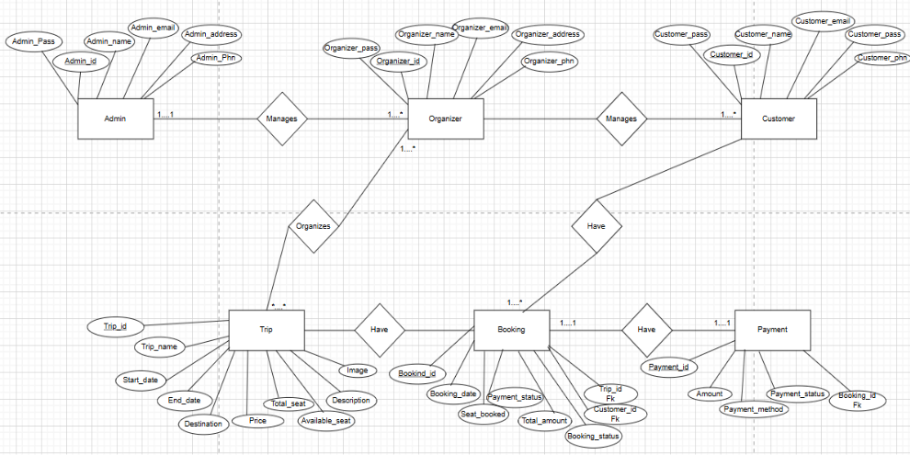

**SQL Queries**

1. INSERT INTO Users (user_name, user_email, user_pass, user_address, user_phn, user_type) VALUES

('First Customer', 'test@example.com', '123', 'Test Address', '01744444444', 'Customer')

('Admin', 'Ramim@gmail.com', '123456', 'Aiub Dhaka', '01822222222', 'Admin'),

('First Organizer', 'First@example.com', '123456', 'Kuratoli, Dhaka', '01933333333', 'Organizer');

2. INSERT INTO Trip (trip_name, start_date, end_date, destination, total_seat, available_seat, price, description, user_id) VALUES

('Test Adventure', '2025-06-01', '2025-06-10', 'Kuratoli', 40, 40, 1200.00, 'Enjoy Aiub, culture, and adventure activities in D building.', 2);

3. INSERT INTO Booking (booking_date, seats_booked, status, user_id, trip_id)

VALUES

('2025-05-01', 2, 'Confirmed', 1, 1);

4. INSERT INTO Payment (booking_id, amount, payment_date, method, status)

VALUES

(1, 2400.00, '2025-05-02', 'Credit Card', 'Completed');

5. UPDATE Users SET user_name = name, user_email = email,

user_pass = pass, user_phn = phn, user_address = addr,

user_type = type WHERE user_id = id;

6. UPDATE Trip

SET trip_name= name, start_date= sd, end_date= ed, destination= dest,

total_seat= tot, available_seat= avail, price= price, description= desc

WHERE trip_id= id;

7. UPDATE `booking` SET `status` = 'Pending' WHERE

`booking`.`booking_id` = bookingId;

8. DELETE FROM `payment` WHERE `payment`.`payment_id` = paymentId;

9. DELETE FROM `booking` WHERE `booking`.`booking_id` = bookingId;

10. SELECT booking.booking_id, payment.amount, payment.payment_date

FROM booking

LEFT JOIN payment

ON booking.booking_id = payment.booking_id and

booking.user_id = user_id

enshots)  
Login Form**

**Register Form**

Admin Add Admin Form

Admin Booking Form

Admin Form

Admin Payment Form

Admin User Form

Create Trip Form

Customer Show Booking

Organizer Form

Payment Form

**Github Link -** <https://github.com/ramimIslam676/Travel_Management.git>